**BILKENT UNIVERSITY**

**ENGINEERING FACULTY**

**DEPARTMENT OF COMPUTER ENGINEERING**

**CS 299**

**SUMMER TRAINING  
REPORT**

**Cüneyt EREM**

**21202398**

**Performed at**

MIA TEKNOLOJİ

(Gazi Teknopark)

01/08/2016 - 26/08/2016

**Table of Contents**

1 Introduction 3

2 Company Information 3

2.1 About the company 3

2.2 About your department 3

2.3 About the hardware and software systems 3

2.4 About your supervisor 3

3 Work Done 4

3.1 Information 4

3.2 Significance of Work Done 4

3.3 Motivation of Work 4

3.4 Hardware-Software Environment 5

3.5 Detailed Description of Work Done 5

4 Performance and Outcomes 5

4.1 Applying Knowledge and Skills Learned at Bilkent 5

4.2 Solving Engineering Problems 6

4.3 Team Work 6

4.4 Multi-Disciplinary Work 6

4.5 Professional and Ethical Issues 6

4.6 Impact of Engineering Solutions 6

4.7 Locating Sources and Self-Learning 7

4.8 Knowledge about Contemporary Issues 7

4.9 Using New Tools and Technologies 7

5 Conclusions 7

References 8

Appendices 8

# Introduction

I have done the internship at MIA Teknoloji in Gazi Teknopark. The Internship was started at 01.08.2016 and finished at 26.08.2016 (20 work day). My department was software department. Company mostly produce android applications of government offices. I chose this company because making android app was my intention.

During the internship, I worked at 2 projects. First one is designing Kiosk desktop app for the Municipality to make municipal work fast. I was only responsible for the design part so that I designed project’s main process which I drew UML, sequences, class diagrams and mock up etc. In the second project, app was for the employees (Construction Company), design of the project was settled and I was responsible for the code part so that I developed an android app for this project which I use android studio to make the app with my teammate.

Rest of the report is based on my entire work during the summer training.

# Company Information

## About the company

MIA TEKNOLOJI is located at Gazi Teknopark. It is a R&D company that providing solutions for the both public and private sectors. Company’s working places mostly contains security systems. For example; biometric identification systems, smart and safe area management systems, health IT systems, biometric switch and control systems, web-based smart and safe campus management systems are some of them. They also highly makes android apps for the both official and private sectors.

## About your department

The company consists of some different departments such as electronic dept. computer dept. business office etc. My department was computer engineering department and they were responsible for the company’s software part.

## About the hardware and software systems

Company mostly uses c# and java because of the android app projects. Also for the security card systems, they were using electronic card systems but electronic engineers was responsible for them. Some computer engineers was writing code for these card systems but interns was not included for this area directly, interns were generally responsible for the coding part.

## About your supervisor

During the internship, different masters helped interns but our head of supervisor was Bedrettin Sümer. His was a senior software engineer at this company and was head of our interns’ department. He was graduated from Eskişehir Osmangazi University in 2012. The address is Gazi University, Golbasi campus, Teknoplaza bz-16, Golbasi, Ankara. His phone number is 0506 824 74 44. His e-mail address is bedrettin.sumer@miateknoloji.com

# Work Done

I worked at 2 projects;

**3.1 Information**

In the first Kiosk project, it provides people with doing their official dealings easily in the town hall. When citizen open the kiosk app on the Kiosk device, he can select some of the options in the program and by following instructions and filling necessary information, they can do his municipal works and do not waste of time because sometimes there is a long line of people in front of the town hall. So, this program help people to make their work quickly. During this project, I designed demo mock-up, use case, sequences and class diagrams. After that, they improve them and write this in android-java to use in windows devices.

In the second MiaCam project, it is designed for the employees (in the construction area) of one of client Company. In this company, employee takes photos of some specific objects such as button, device, lock etc. But they send these photos by USB. This cost a lot of time and very hard so that they want our company to do an app that takes 6 different photos. During the taking photo, user can confirm the photo or can cancel the last taken photo. After taking photos, they will be saved not only into device, but also company’s specific dropbox account. Each employee has a name and sub office name. So, this makes employees’ work quick. I coded major parts in android studio.

**3.2 Significance of Work Done**

First project’s purpose was to find a solution for a real world problem. There are some Kiosk devices in the town hall but people do not use them because these devices are not useful and are complicated. When citizen wants to use these devices, they do not understand how to use and do not want to fill all spaces in the app that we saw this problem in that spot. So that to improve Kiosk’s functionality, our company wanted to start this project.

In the second MiaCam project, client firm was struggle of losing too much time when they do their work. Lots of employee does not know how to use some apps so that after app’s design is clarified, we coded it. This app will be used all of offices of the client company so that it was important to us.

**3.3 Motivation of Work**

In the first kiosk project, I was motivated because it was real life problem. I joined meeting about this project and observed how Kiosk devices manufacturing and how software part should be written. Also, I took the cs319 course in the last semester so that drawing diagrams in real project exited me.

In the second MiaCam project, despite it was solving real life problem, exciting part was learning making android app for the first time from my aspect. I wanted to learn making android app before but I could not start for some reasons so that this project was an opportunity to write android codes. Also I enhanced my java skills over the swing feature.

**3.4 Hardware-Software Environment**

In the first kiosk project, I drew class, sequences, use case diagrams and I used StarUML program. This kiosk app fits in windows environment. In second project we used android studio (java) to develop android app.

**3.5 Detailed Description of Work Done**

In the first kiosk project, it was based on windows desktop app. To use this kiosk app, user inserts his ID card (e-kimlik card). And he writes his password to the screen, after click ok, app goes to main menu (program automatically read data from ID card and confirm password). There are some of selections that user can do his town hall services such as “bilgi edinme hizmeti”. If user clicks on it, there will be two or more options. For example if user wants information about services, user should fill necessary data like TC no, name, tell etc. and click apply button, then user receives confirmation message and goes to main menu to use another service or exit. During this project, I designed mock-ups that how project will run on and other diagrams to show programs process how it works. To do that better, I read some of articles about e-ID card how it works and observed how current kiosk town hall app runs. Also, I attend one meeting about manufacturing of kiosk device to see how machine would be designed and software should be designed

In the second MiaCam project, when user runs the app, after he fills user name and office name, camera app starts to ready to take pictures. There is a symbol of the view on the middle of the screen. When user click on the symbol, camera auto-focus works. When user takes photo, there is a confirmation screen that shows user the photo and yes or no buttons. If he clicks yes, second camera screen shown. If user clicks no, user takes the same photo again. There will be six photo taking actions. They are button, device, lock, before preperation, bun and report. After user takes these photos, last screen will be shown that includes all six photos, user’s name and office name as well as three buttons which are main menu, send and exit. After he clicks on send buttons, after dropbox account is confirmed, photos will be sent to the specific company dropbox account and into the device itself. If user wants to cancel it, user can click on the main menu or exit buttons. During the coding, “Intent” methods were very useful and crucial for the android that was the main difference and I never seen it in java before. Some important methods are different typical java methods such as onCreate method. Some of parts were hard to me especially not to lose any data when using Intent method to pass one class to another. In java, set and get methods are useful but in android java, this is different. So Android studio was fun for coding.

Here are details of the project 1 and 2;

First Project:

Use Case Diagram

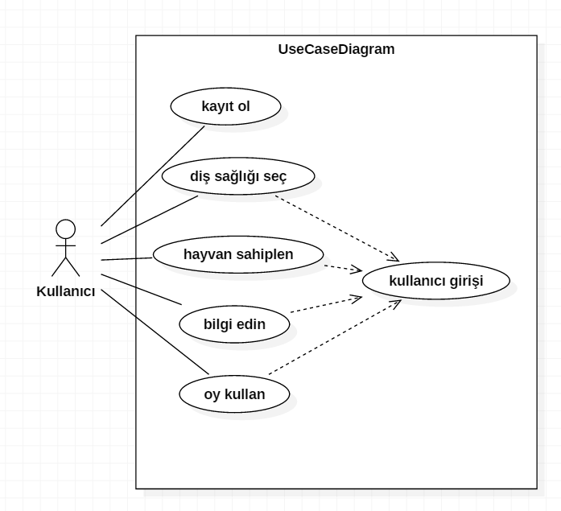

User can use some functionalities in this app. After he register and enter on the system, he can select ‘dental health’, ‘animal ownership’, ‘learn about us’ and ‘vote the app’. All of these functionalities are required from the city hall online. Here is one example of the use case scenario;

Use case #1

Use case name: register on the system

Participation actors: player, system

Entity condition: user clicks on ‘register’ button, system process starts

Main flow of events:

* user clicks on ‘register’ button
* system loads the screen of the register page
* user fill the necessary blanks about himself and clicks ‘ok’ button
* system receive info and send them to the database and also it send confirmation message to the user’s e-mail
* user confirms the confirmation message and can enter the system

Sequence Diagram

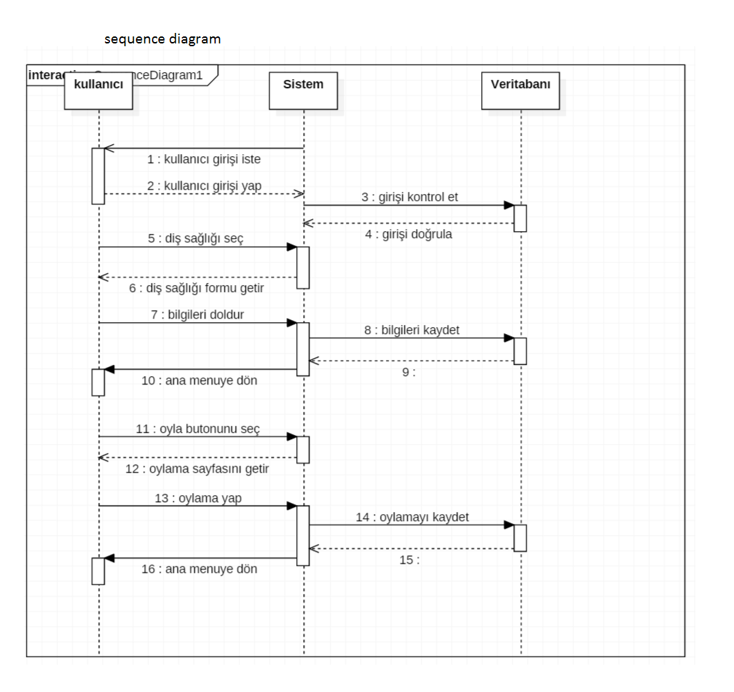

* When user starts the app, system wants username and password from him.
* System checks whether user account is valid or not. It sends the info to the database and if it is valid, database send confirmation info to the system and user can enter the app. If account is not valid, it wants valid account.
* If user clicks on the ‘dental health’, system gives the ‘dental health’ page which includes form that will send to the system to be observed later.
* If user fills the blanks and select the ‘ok’ button, system send these info to the database to be stored and user goes to the main page.
* It does the same process for other functionalities such as ‘vote the app’

Model Class Diagram

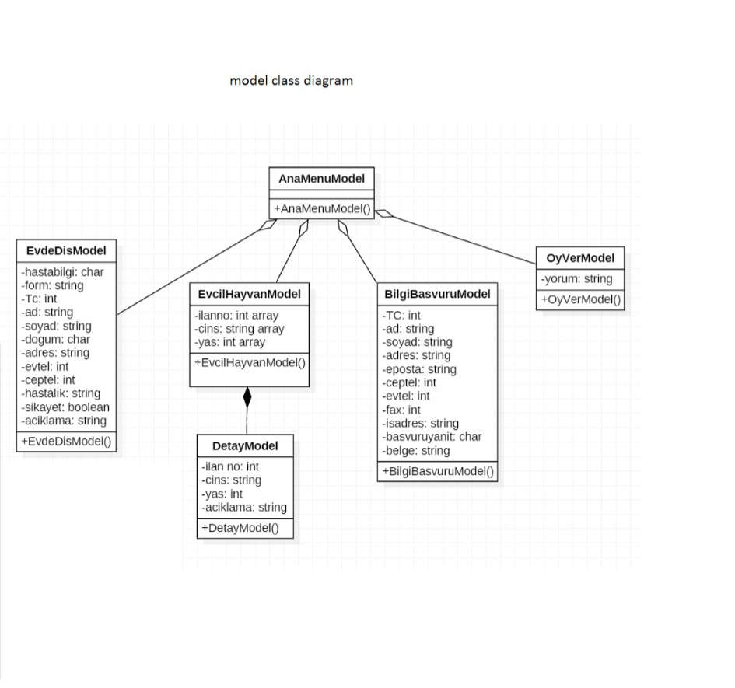

Model view classes keep the necessary information when all of them filled by the user and clicked on the ‘ok’ button. For example, ‘dental health’ keeps the ‘patient info’ in char type. It hold the name, surname, address, and patient as string and hold the TC no, tell no as integer. All of these functionalities are defined by the city hall standards. After these model classes keep the necessary info, system send these info to the database.

View Cass Diagram

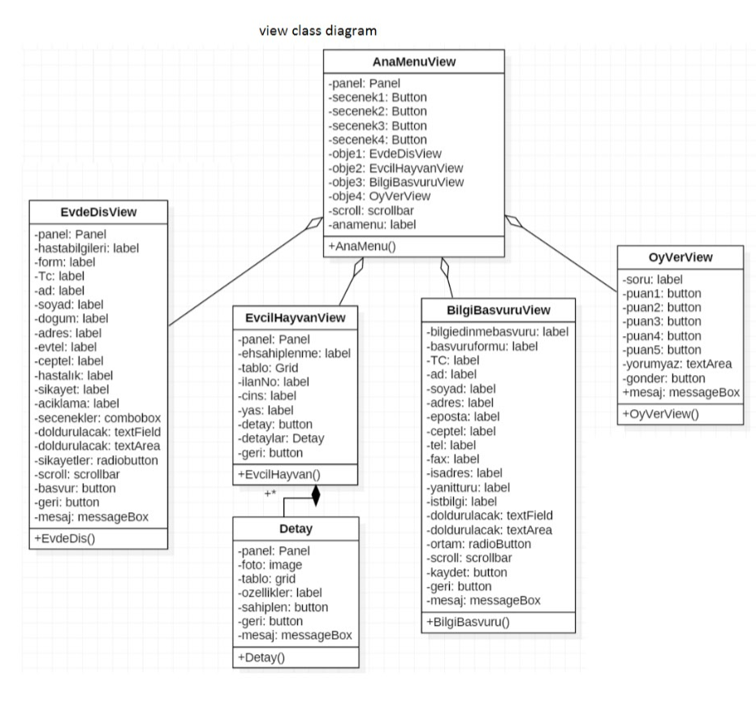

AnaMenuView class keeps the main page view objects. It has panel, four button to be selected, four different object to be used, labels about info and scrollbar. There will be four big view classes four of which are ‘dental health’, ‘animal ownership’, ‘about us’ and ‘vote the app’ views. All of these views hold the user interface properties such as panel, labels, combo boxes, buttons, text fields, text areas etc. All of these first load the page and other options properly for the app page.

Mock Up

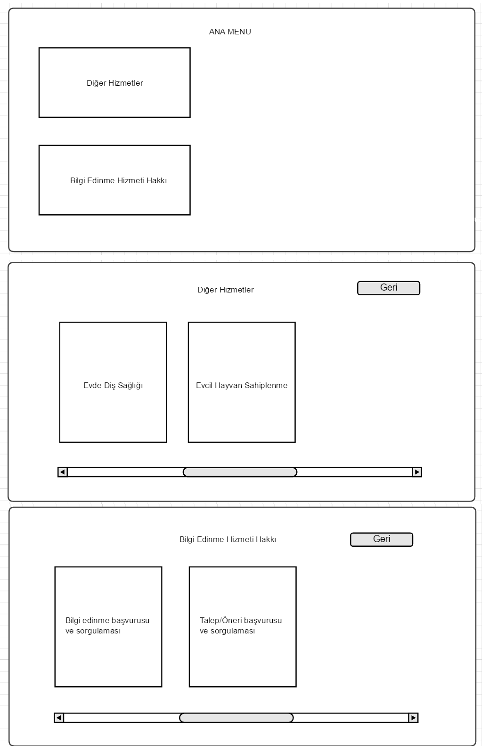

After user enter the system, main page includes two different option. If he clicks on ‘other services’ button, next page which includes ‘dental health’ and ‘animal ownership’ will be shown. If he clicks on ‘information service’, two other options will be shown on the screen. User can use scroll bar and press ‘back’ button to return back.

Sample of four main functionalities’ mock up design

In the ‘dental health’ part, user should fill the planks and select the necessary options. For example, when he define his illnesses by defining name, illness, description uses text fields, he should also check the complaint part which uses combo boxes. Similar mock ups are designed for other app pages.

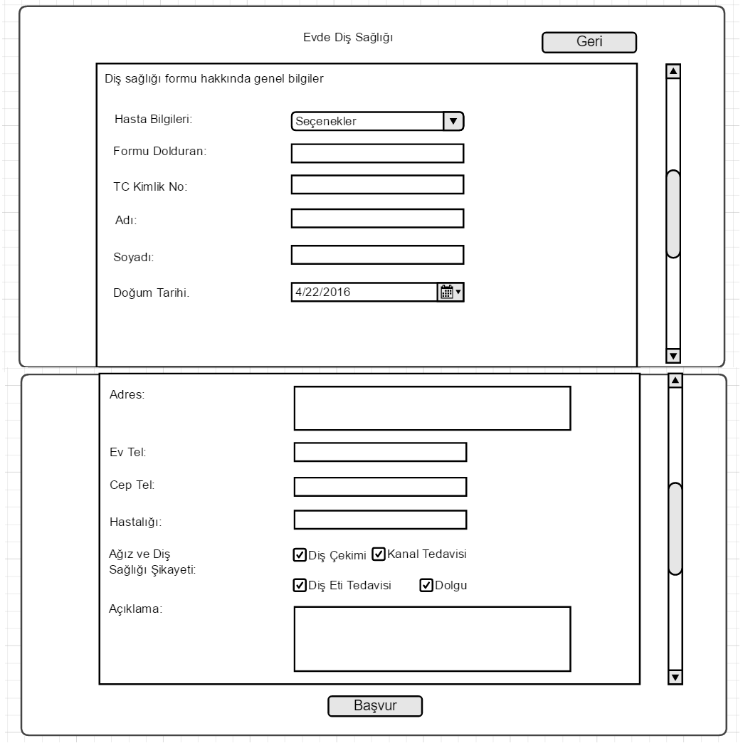

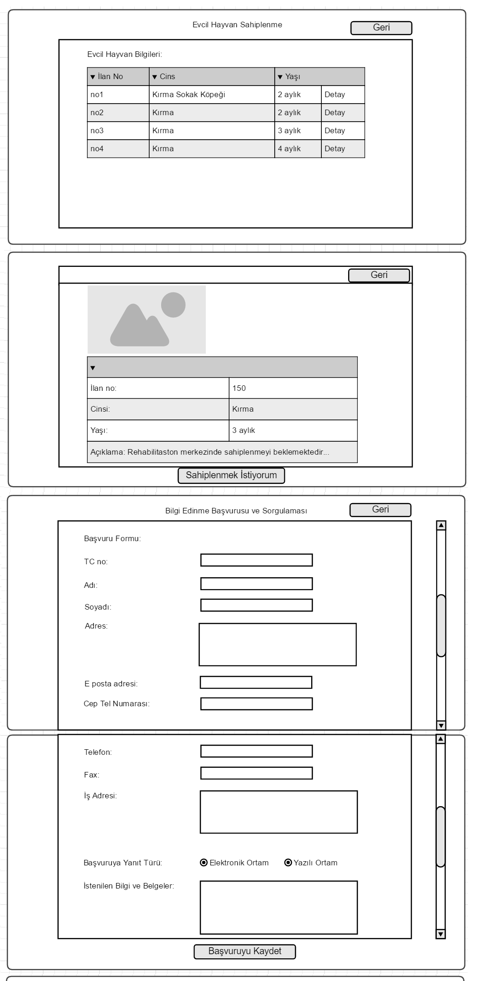

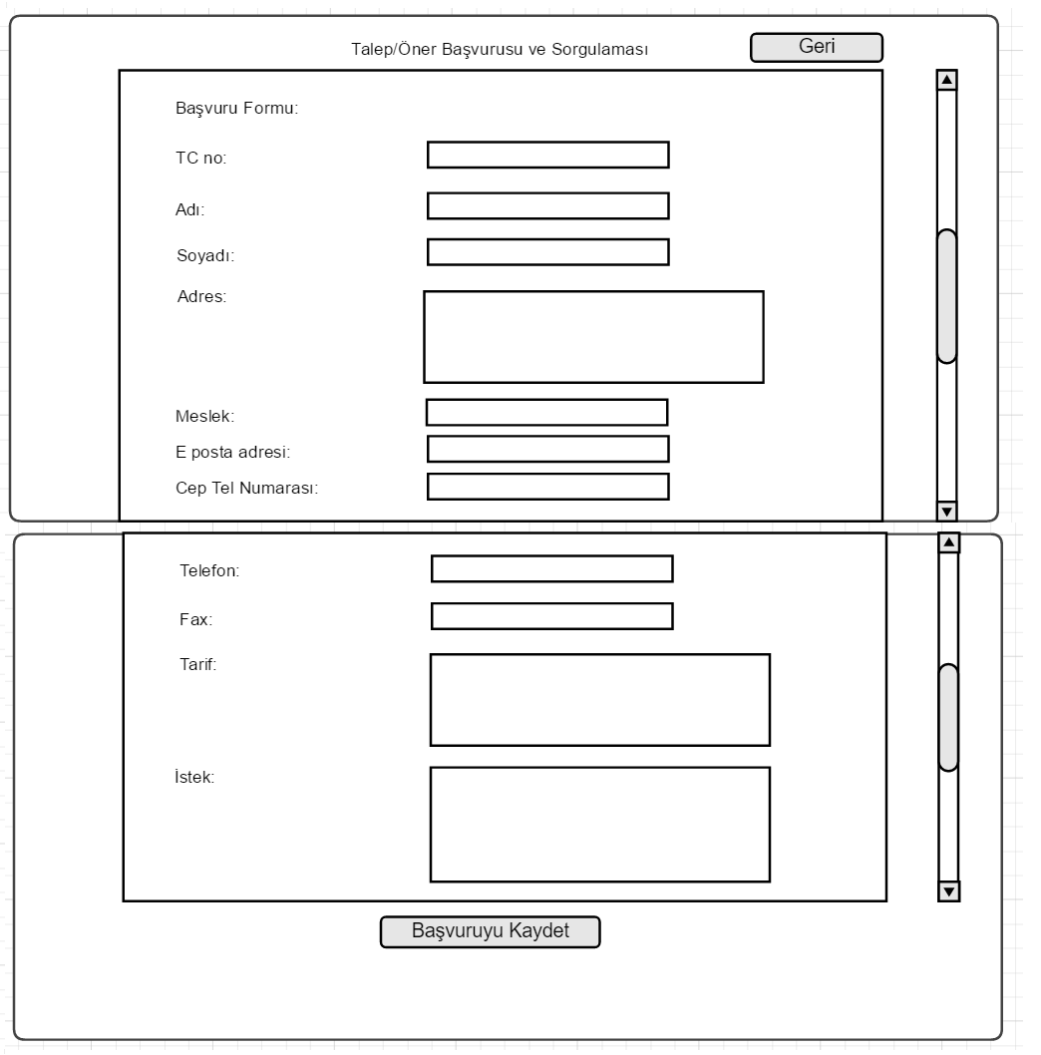

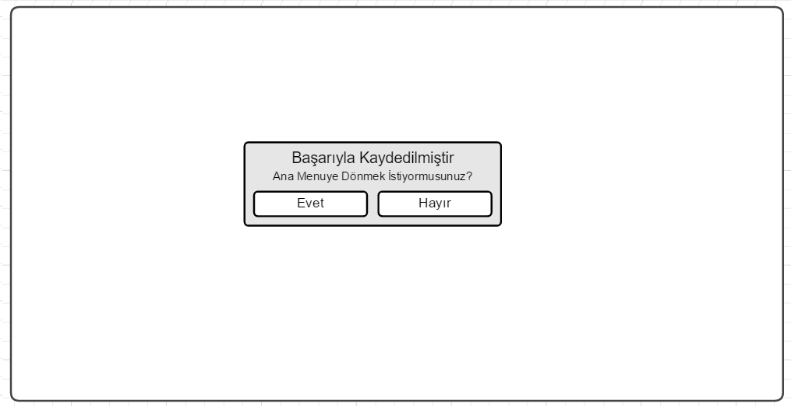

Second Project

Second project is camera based app designed in Android Studio. In MainActivity onCreaate method, I used Intent function to start the activity and go to next SubeAdi class by clicking on ‘basla’ button. In SubeAdi class onCreate method, user enters username and office name. To send these info to the other classes, I used sharedPreferences. If user clicks on exit button, activity ends by finish () method. If user clicks on start button, it goes to cam1 class.

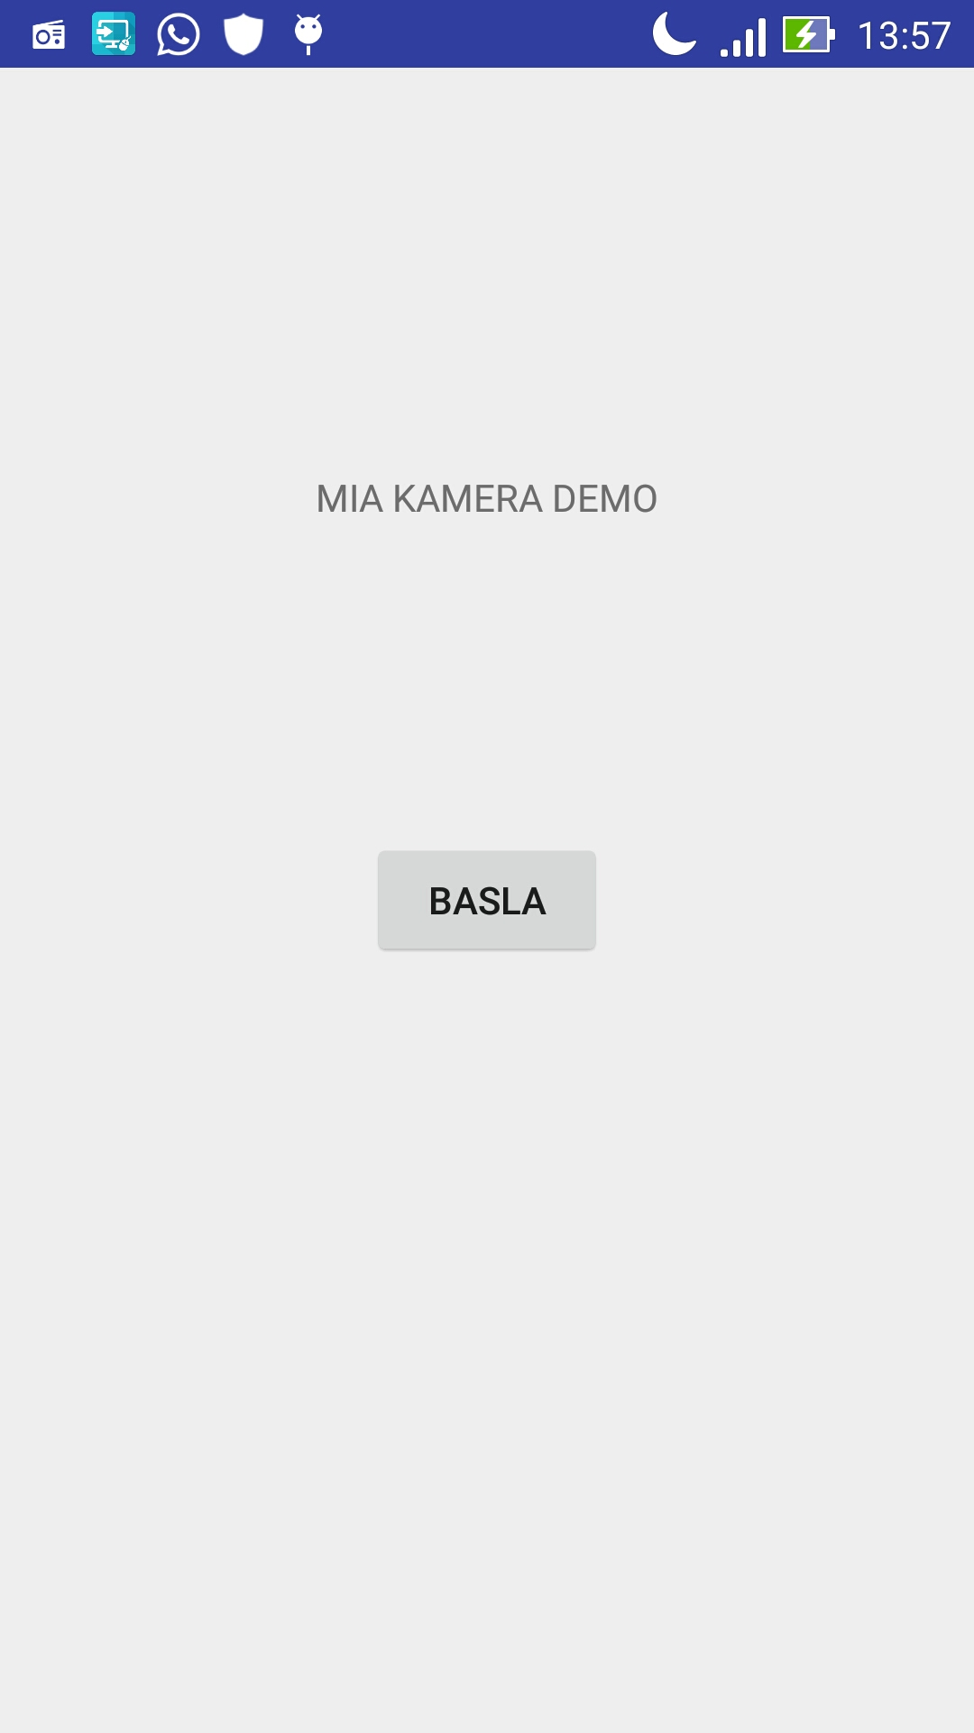 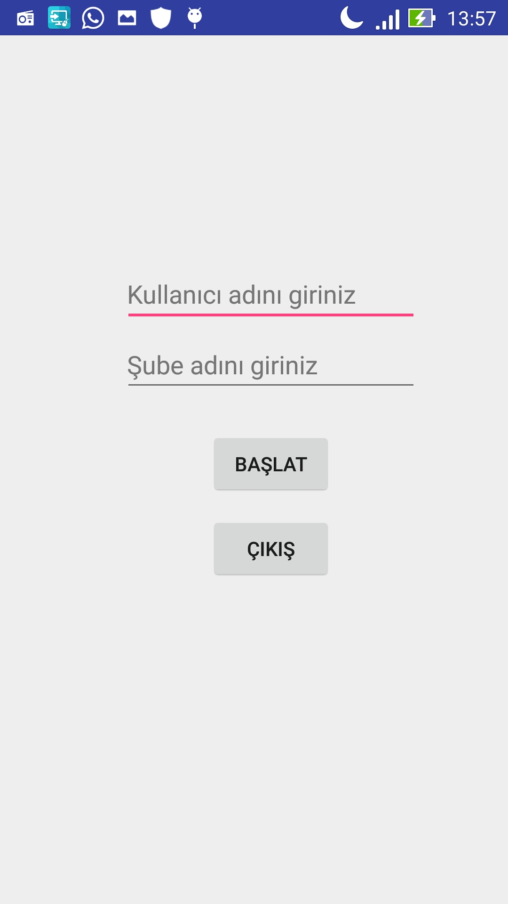 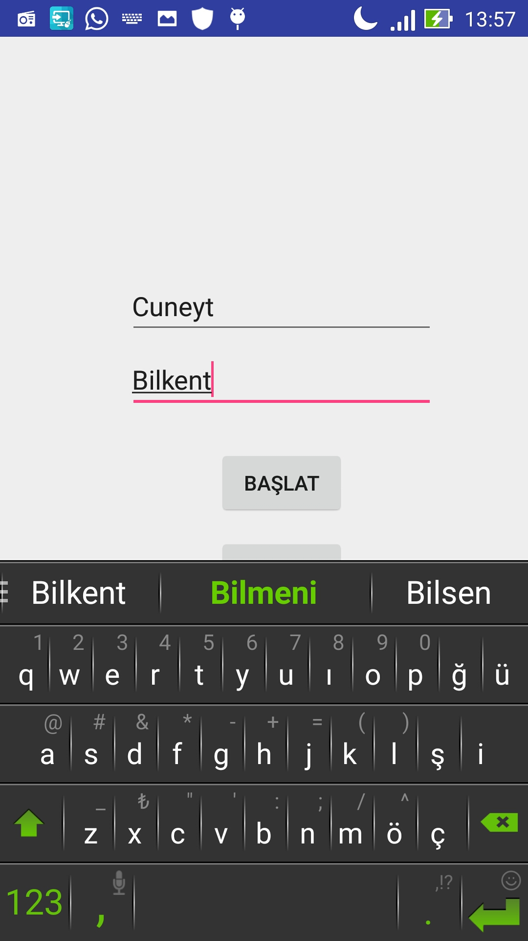

There are six cam classes. After six photos taken by the user, it goes to confirmation screen. In each cam classes, there are camNext classes which wants user to confirm the photo to be accepted or keep continue to take new photos. To pick the photos and show the camera facilities, there is a cameraView class which is designed by my teammate. He used surfaceCreated, surfaceChanged and surfaceDestroyed methods for this class which simply provides to show camera action.

In the cam1 to cam6 classes, I used cameraView class to show action and also Camera to keep photo taken. After cam1 screen comes, in onCreate method camera opens with Camera.open() method, if user cliks on the midle of the screen, camera focuses automatically by autofocus(null) method. If user clicks on take photo image button, camera takePicture method send the bitmapped picture to the onPictureTaken() method and it sends to the cam1.Next class by Intent.putExtra() method. In cam1Next class, taken photo is shown and there are two options that user can confirm and nex stage cam2 screen and photo will be saved in file in the phone by using fileoutputstream by creating dirr class and saving photos by their specific names such as ‘buton’ and ‘cihaz’. If user clicks on no button, it will go directly to the back stage without saving photo using Intent method. Same processes are valid for cam1 to cam6 and cam1Next to cam6Next classes.

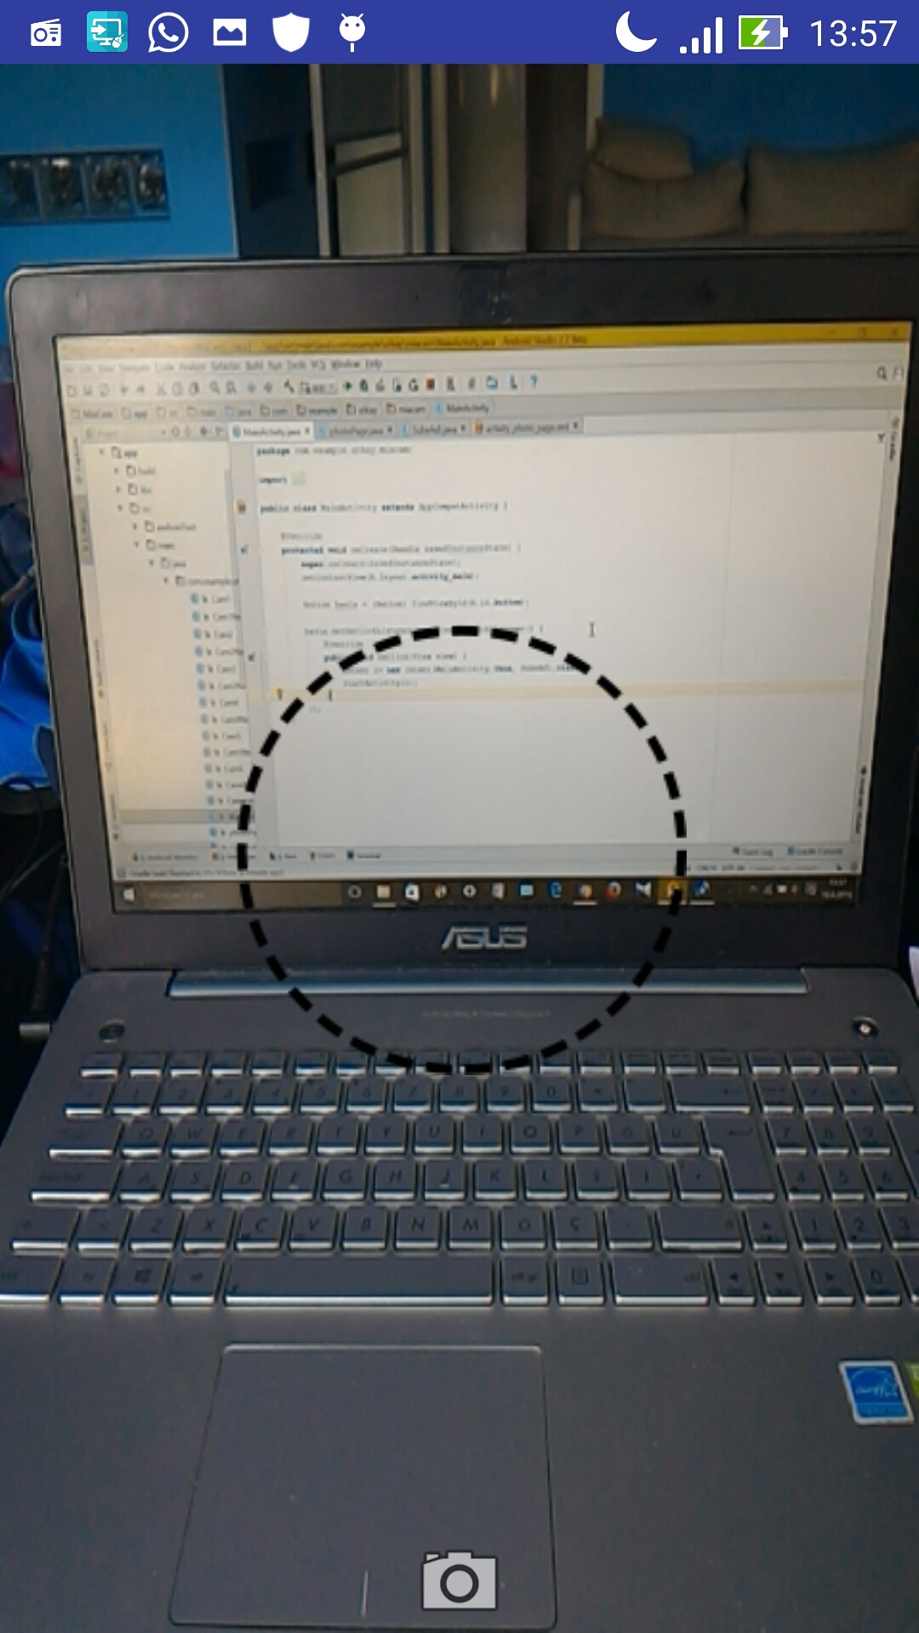 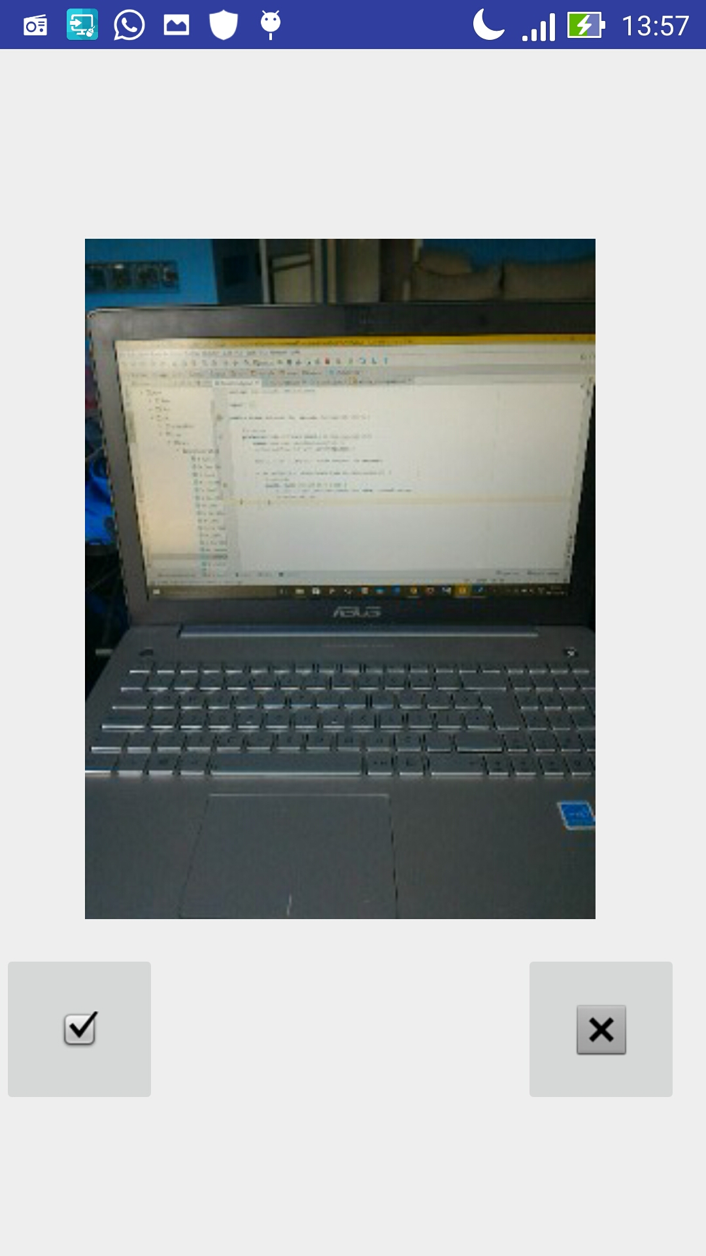 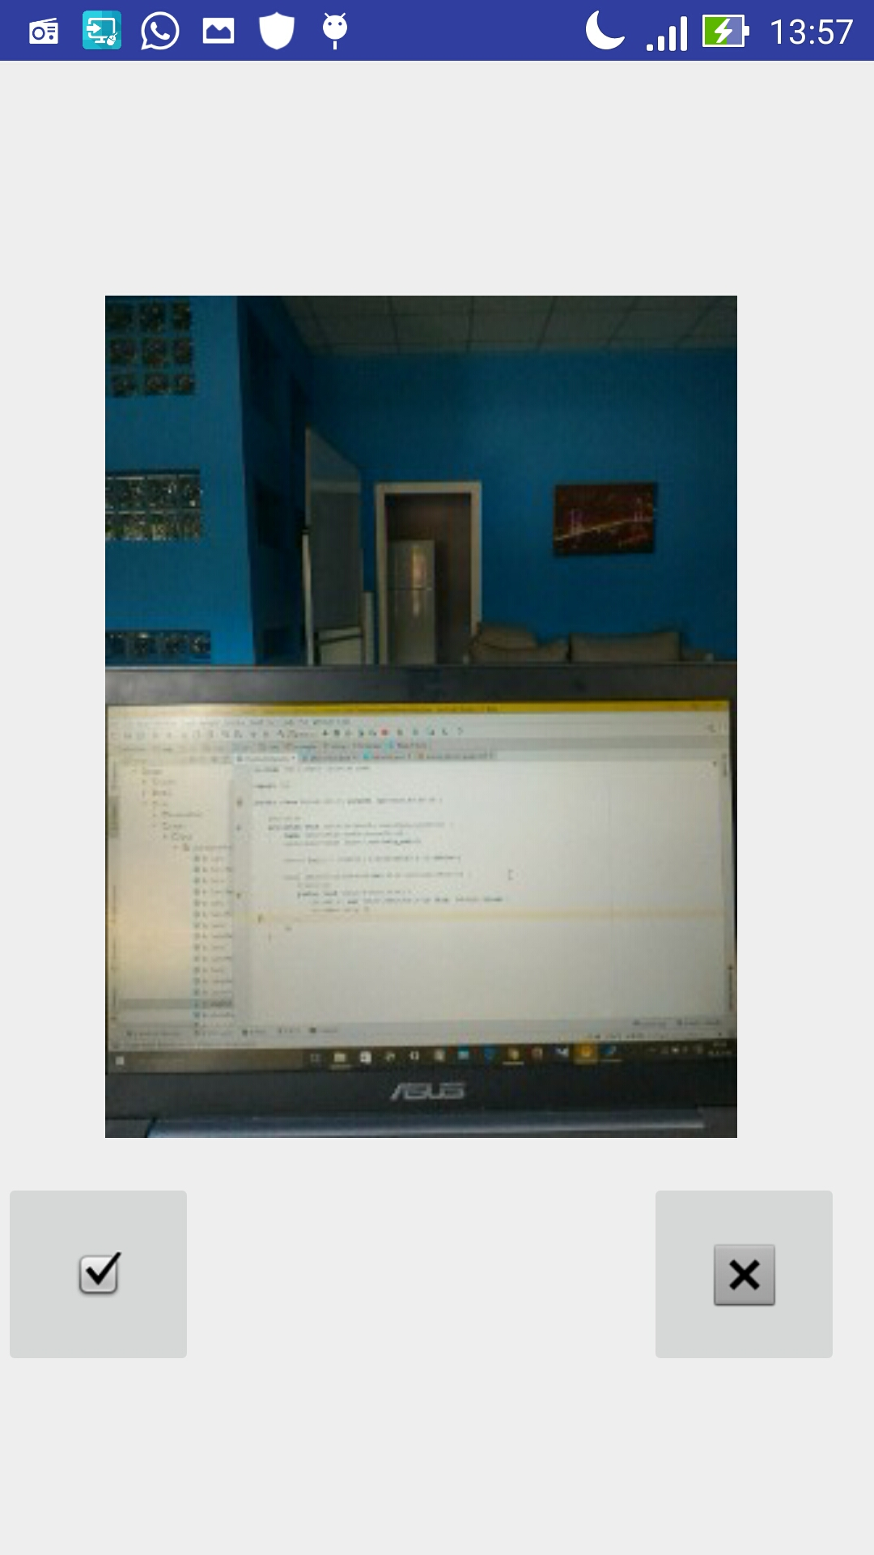

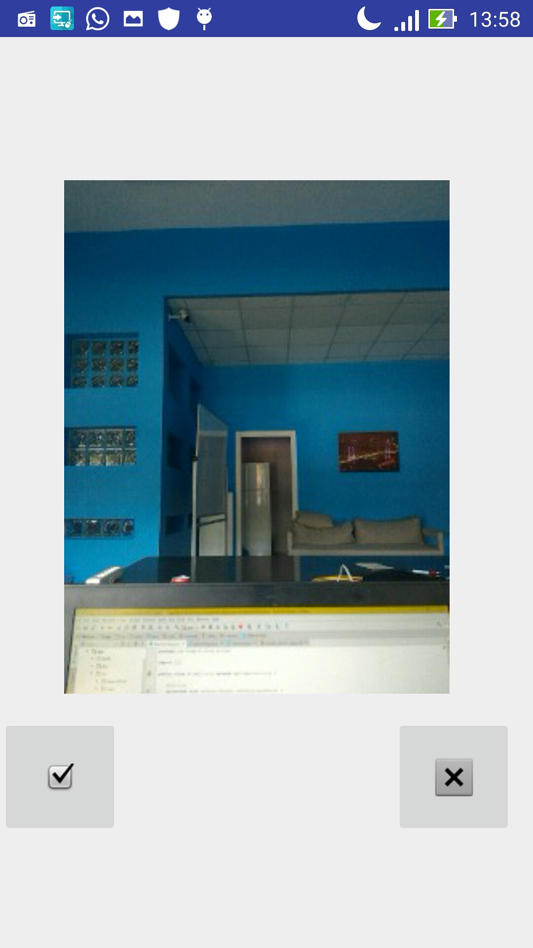 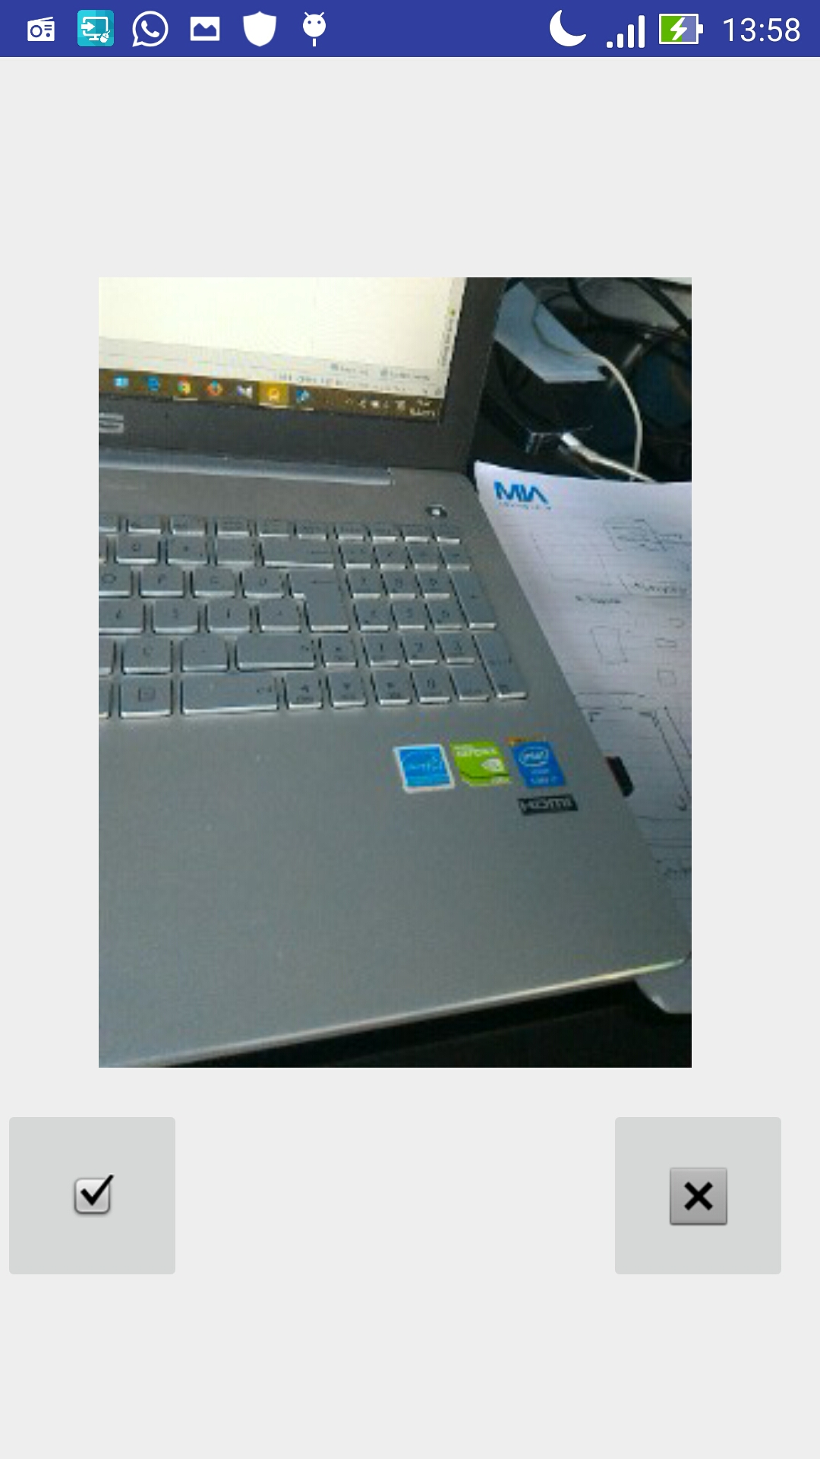 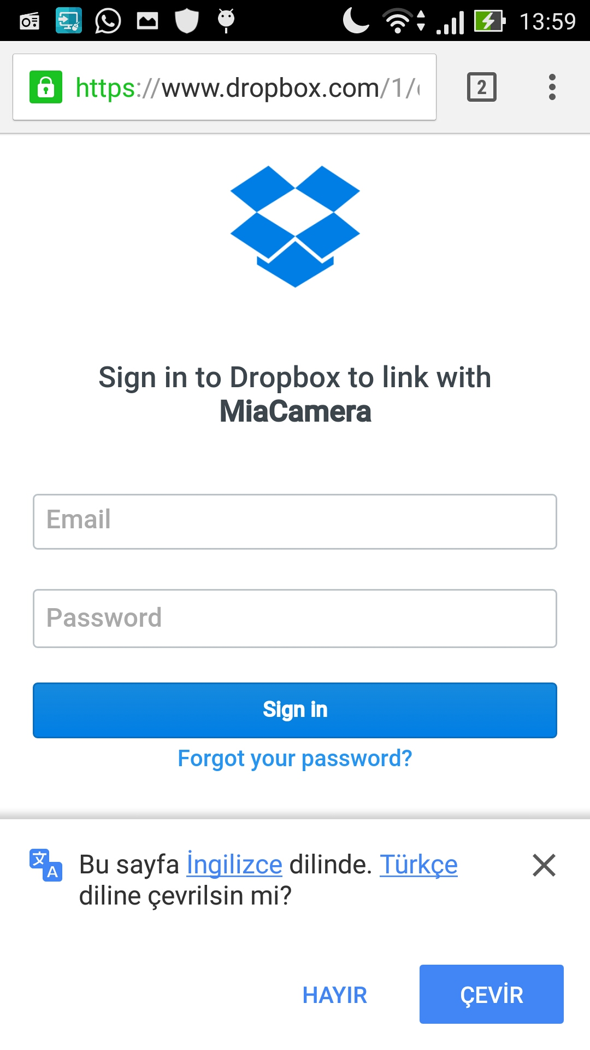

After cam6Next phase done, photoPage class stage is come. Here, all taken six photos, username and office name are shown. Name and office name are received by using sharedpreferences method and put into TextViews, photos are received from File getExternal storage facilities and put into ImageViews. If user clicks on ‘send’ button, dropbox confirmation screen comes to be approved and all photos will be send to the company’s specified dropbox account and message dialog will be shown to inform user that messages sent and ‘send’ button will become impressible. If user clicks on main page button, it goes to that page or exit from app directly without sending photos.

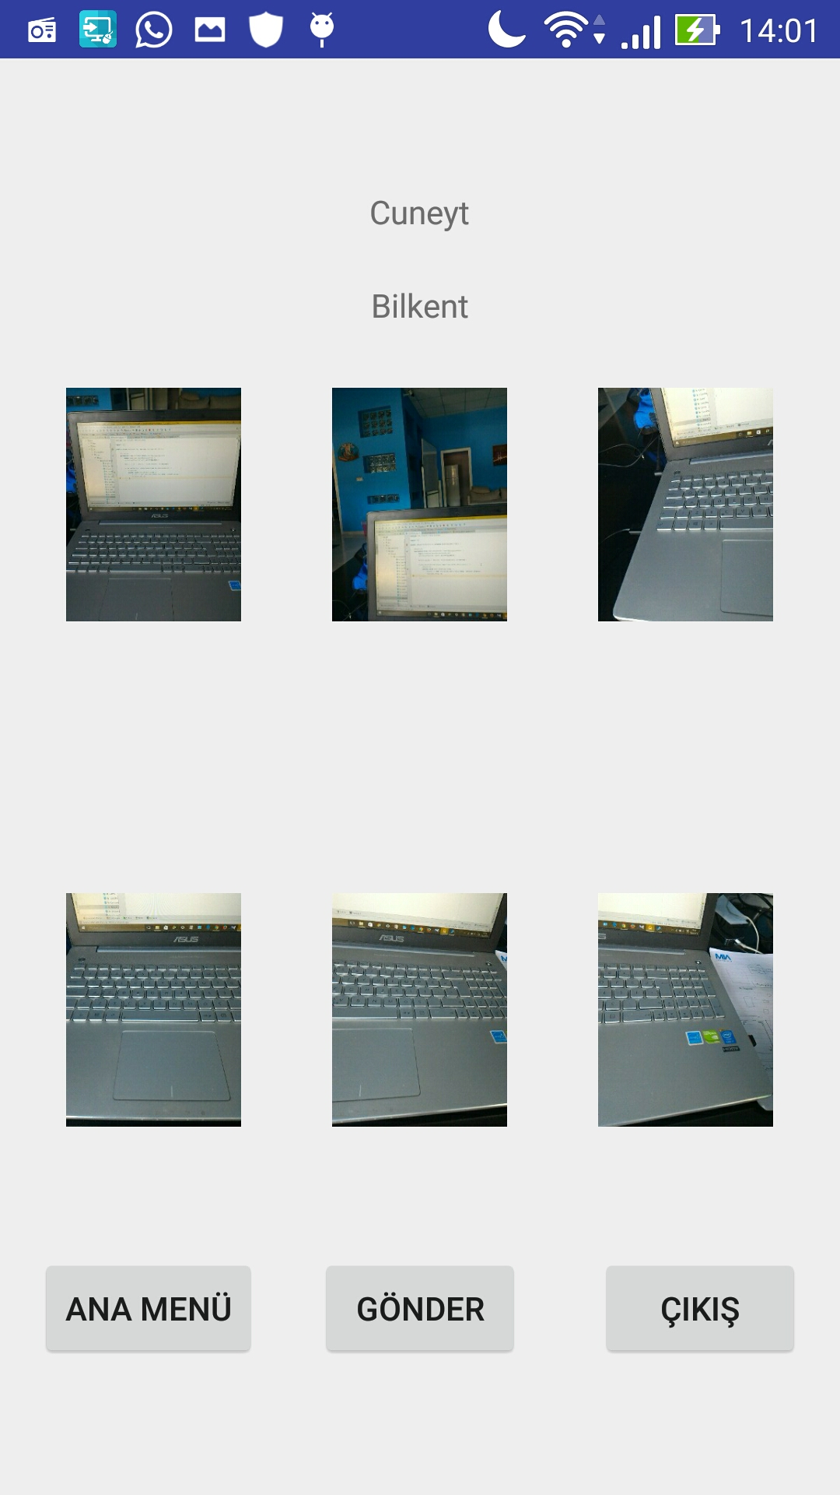 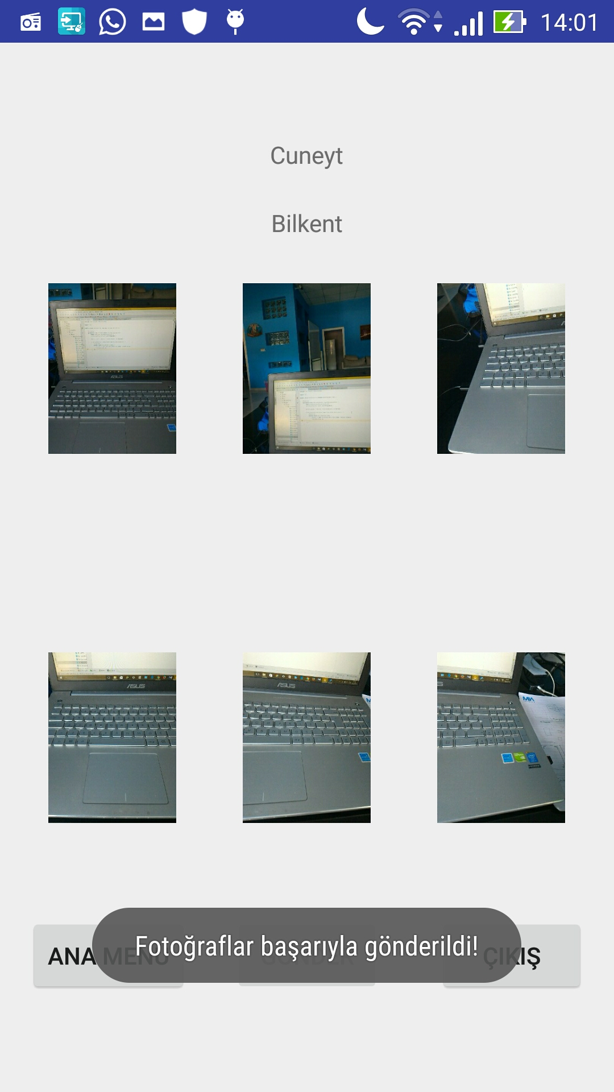 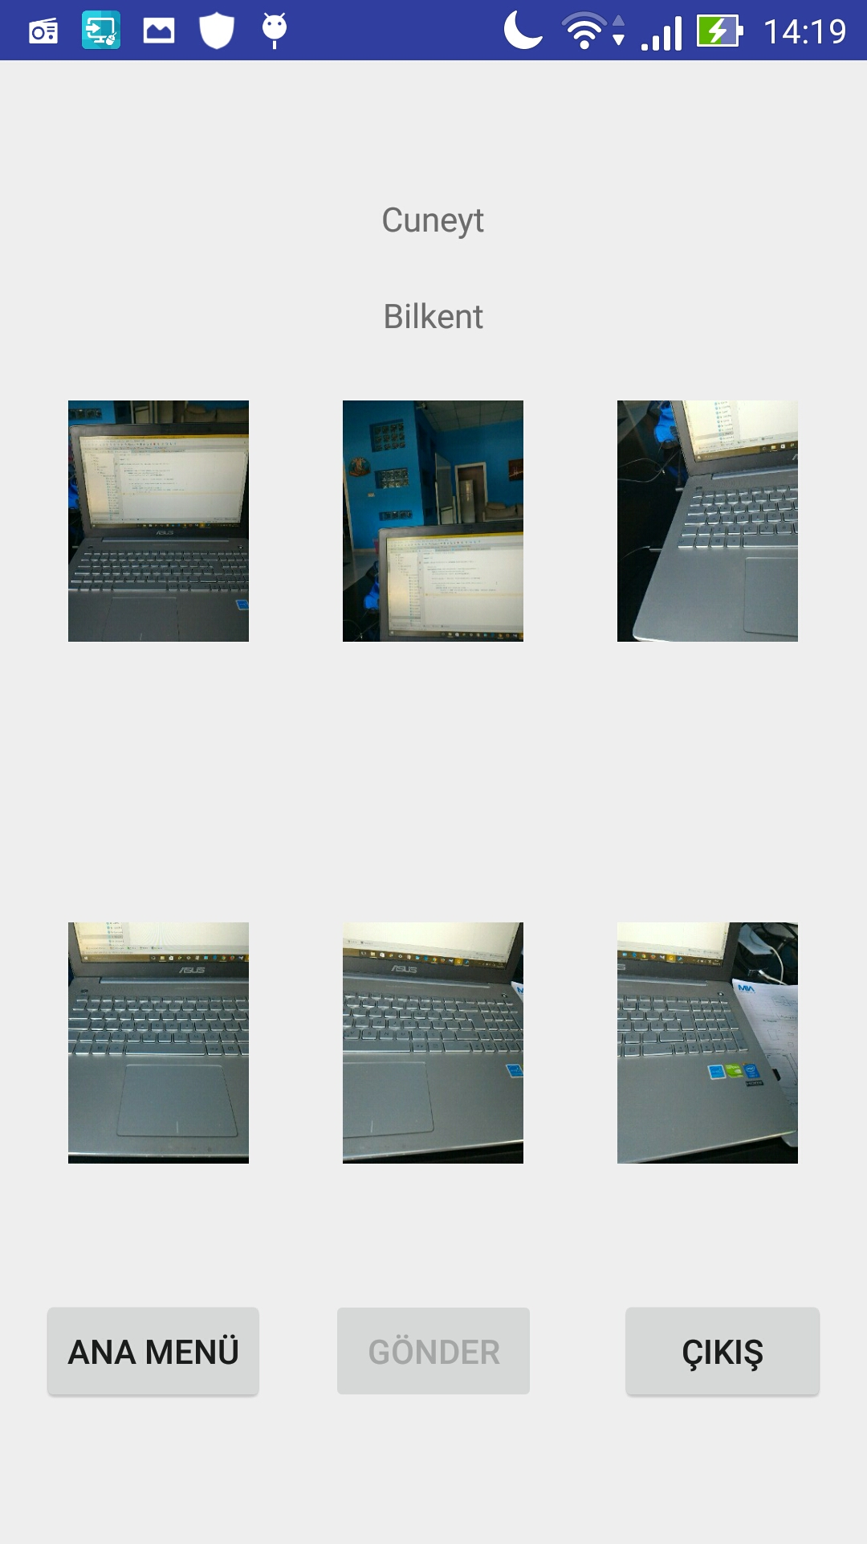

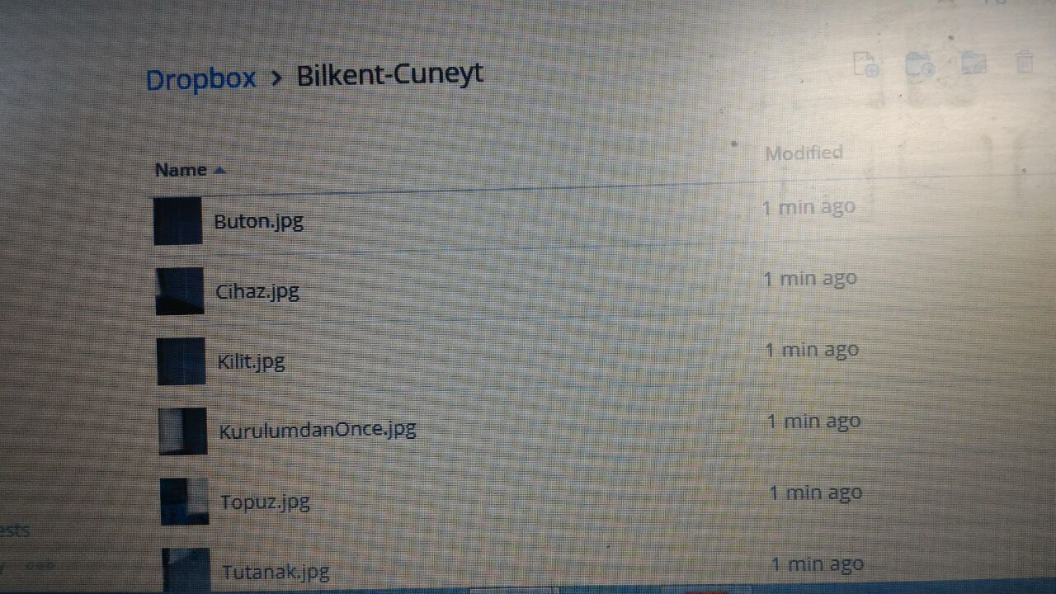

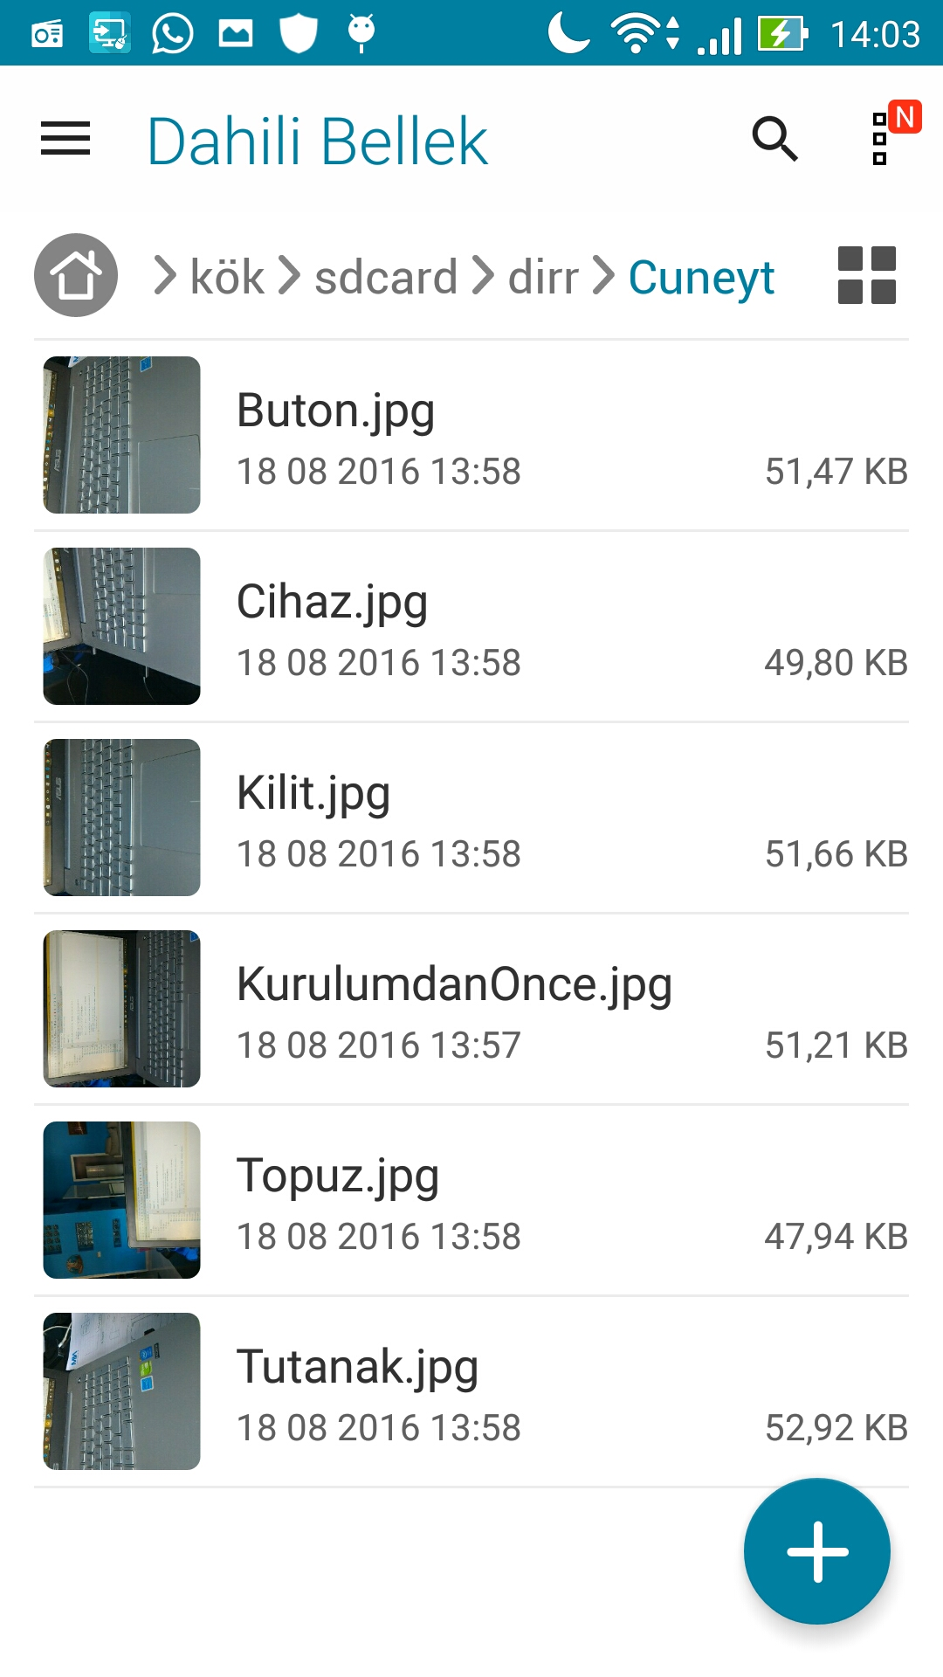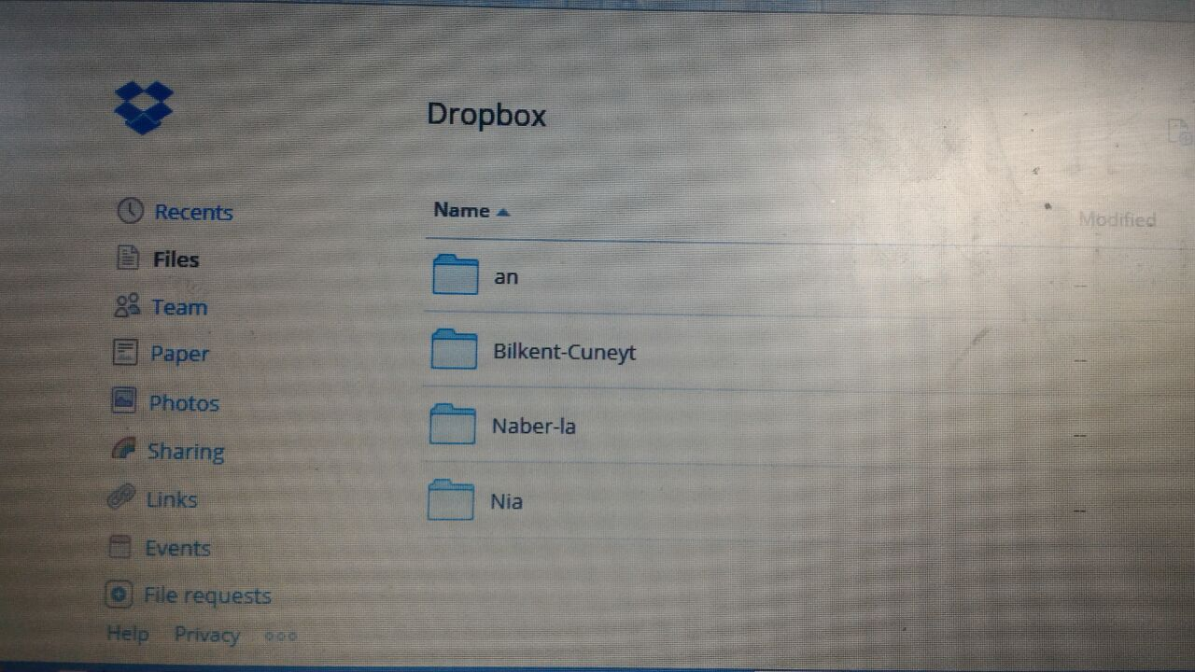

Codes can be seen in my GitHub account [6].

# Performance and Outcomes

## Applying Knowledge and Skills Learned at Bilkent

Applying knowledge in real life experience was fairy enough for me. For example in the first project, I have to design the process of kiosk desktop app so that I used MVC patterns (from cs102) and drew mock up, class, sequence and use case diagrams (from cs319). Coding part was entirely based on my all cs lessons. I had to make android app which is mostly based on java so that cs101, 102 and 319 classes helped me to write java code and learn some new things (learning xml and other android studio tool parts did not take much time).

## Solving Engineering Problems

In the first project, it was municipal app but exact specifications and features of the application was not clear so that we researched similar applications online and traveled to the town hall to observe current systems. After that, we decide how app should look like and work and I started to design project but sometimes my responsible supervisor wanted to change some features so that I redrew diagrams and mock up again and again until last view satisfied us.

In the second project, we were coding of cam app. When we faced problems, asking and searching google was crucially helped to us. But sometimes supervisor wanted us to add new features and change some things a bit so that despite recoding was hard, searching online helped us.

## Team Work

In this project, there was only one engineer and one intern so that designing part was entirely up to me. After I finish my work, I showed my diagrams to the supervisor and he corrected me. During this stage, I learned master-apprentice relationship closely.

In the second project, we were two member team. Design of the app was definite so that during the coding, some camera classes and linking internet server part was his area of responsibility. I was responsible of main part such as interface, almost whole process of running app (taking photos and saving them into both memory of the phone and definite dropbox account, taking 6 staged camera step confirmed by the user etc.).

## Multi-Disciplinary Work

All team members and my supervisor were computer engineers so that there was no different disciplines except from being different school members. I realized that some of the interns were not good at designing part so that I finished first project alone. In the second project, my team member was good at android development so that my partner and I were assigned to the android camera app. Other interns were assigned different android app projects that did not so hard. While we were coding, he did his area better like server part, I did my area like main steps of app.

## Professional and Ethical Issues

During the internship, interns saw that doing job professionally is important. For example, being in the office at exact hour was very important. If you did not make it in time, you will be punished (not for the interns). In some projects, not sharing codes were very important ethical rule. If you share codes with someone else, this means you will be punished by paying lots of money (But we were not responsible those highly important projects). Reasonable excuses were acceptable but fooling the company was unacceptable, for example, my first responsible master was fired because of his unsuitable behaviors. That scared of interns in that time.

## Impact of Engineering Solutions

My first project required city hall with saving time, money and gaining satisfaction of the public because current town hall kiosk devices were not suitable for the people. Second project designed constructors’ of one company that make their work quick. These impacts were local.

## Locating Sources and Self-Learning

During the internship, I learned lots of things by googling. Mostly I used stackoverflow website to correct mistakes of the code. [1] Also I watched youtube videos (derek banas) how to make android app quickly. [2] Sometimes, I asked questions to other interns and engineers.

## Knowledge about Contemporary Issues

I used MVC patterns, drew mock up and diagrams, coding android in latest version so that I guess these works were contemporary.

## Using New Tools and Technologies

For drawing diagrams, I used StarUML tool. [3] For the mock up, I used online website tool. [4] During the cs319, I already used some of diagram tools so that I did not work to learn it. I know how to draw use case diagrams, sequence diagrams, class diagrams should be draw in this tool and designing mock ups well. For the android app, I used Android Studio tool for the first time. [5] For this tool, I read tutorial of the android studio webpage and watched some videos about it. So, I know how android studio tool should be used at good level.

# Conclusions

I worked two good part of the works. Designing and coding experience were good for me. I did not only use my school knowledge, I used them in real projects so that that was good. Also I wanted to learn android app but I did not work on it before so that learning of coding android was good for me. Also during kiosk project, even if I only responsible of design part, I learned how kiosk devices work and see its hardware part. So, it was nice experience for me.

# 

# References

[1] “Most I used website”.

<http://stackoverflow.com/> [August, 2016]

[2] “learned making android app from this videos”.

<https://www.youtube.com/watch?v=nBD4xhH5vIE&list=PLGLfVvz_LVvSPjWpLPFEfOCbezi6vATIh> [August, 2016]

[3] “diagram tool”.

<http://staruml.io/> [August, 2016]

[4] “mock up tool”.

<https://moqups.com/> [August, 2016]

[5] “android studio tool”.

<https://developer.android.com/studio/index.html> [August, 2016]

[5] “GitHub miacam codes”

<https://github.com/cuneyteremcs/MiaCamProject>

# Appendices

Diagrams are shown in previous pages as instructor said and projects are explained in more details.

**Self-Checklist for Your Report**

*Please check the items here before submitting your report. This signed checklist should be the final page of your report.*

* Did you provide detailed information about the work you did?
* Is supervisor information included?
* Did you use the Report Template to prepare your report, so that it has a cover page, the 8 major sections and 13 subsections specified in the Table of Contents, and uses the required section names?
* Did you follow the style guidelines?
* Does you report look professionally written?
* Does your report include all necessary References, and proper citations to them in the body?
* Did you remove all explanations from the Report Template, which are marked with yellow color? Did you modify all text marked with green according to your case?

Signature: _______________________